
Kindergarten 2024-2025 Supply List
Please LABEL the following with student name:  - 1 clear pencil box (standard size)  - 1 blue pencil box (standard size)  - 1 Fiskars student round tip scissors  - 2 Plastic red folders with clear view pocket by Five Star  - 1 spill proof water bottle (no pop culture or stickers)  - 1 backpack (no wheels; no pop culture or any dangling accessories)  - 1 lunchbox (no pop culture) | Please DO NOT LABEL the following: (These are community supplies)  - 4 thick colored Expo dry erase markers  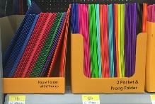  - 4 individual packages of Crayola Classic Color crayons (24 count)  - 1 package of Elmer’s Disappearing Purple glue sticks (4 count)  - 24 yellow Ticonderoga #2 pencils (We can only use Ticonderoga)  - 3 plastic folders with prongs  - 1 green  - 2 blue

