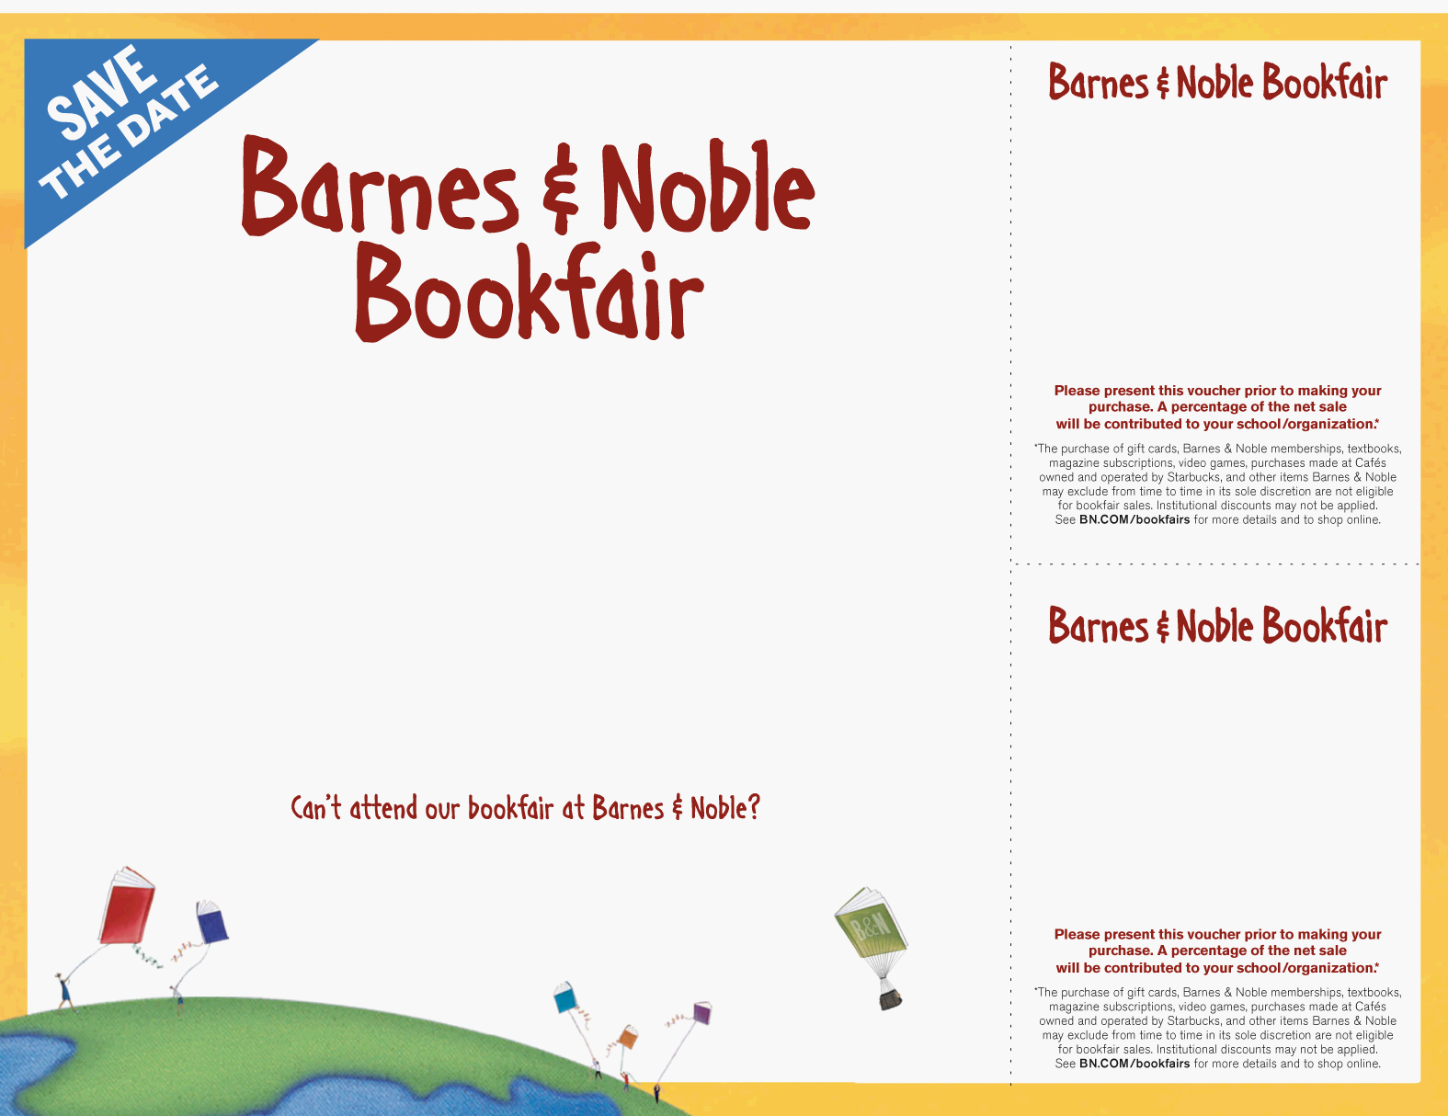

Sunday May 26th - Saturday June 1st
Palm Valley Pavillions West
1446 N. Litchfield Rd.

It’s time to get your 2024-25
Consumables!

Visit BN.COM/bookfairs to support us
online from 5/26-6/6 entering
Bookfair ID 12763967
at checkout.

supporting

Roosevelt Archway
Sun. May 26th – Sat. June 1st

Barnes & Noble
1446 N. Litchfield Road
,
Goo

Bookfair ID 12763967
supporting

Roosevelt Archway

Sun. May 26th – Sat. June 1st
Barnes & Noble
1446 N. Litchfield Road

Bookfair ID 12763967
Archway Roosevelt

